34.95: Parallel light coming in from the left is focused 12.0 cm from the left lens, which is 8.00 cm to right of the second lens. Therefore: 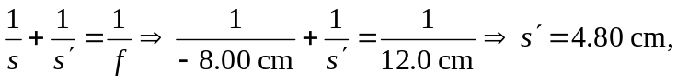 to the right of the second lens, and this is where the first focal point of the eyepiece is located. The second focal point is obtained by sending in parallel light from the right, and the symmetry of the lens set-up enables us to immediately state that the second focal point is 4.80 cm to the left of the first lens.

